- Create empty plots with specified axis limits.

Aim:
To create empty plots with specified axis limits.

Procedure
Step 1: Open RStudio or R console on your computer.
Step 2: Remove the variable named c from the workspace using the remove function. Step 3: Use the plot function to create an empty graph by sefling the type as "n".
Step 4: Define the range of x-axis and y-axis using xlim and ylim. Step 5: Label the x-axis and y-axis with appropriate names.
Step 6: Run the program to display an empty plofling area ready for adding points or lines later.

Code:
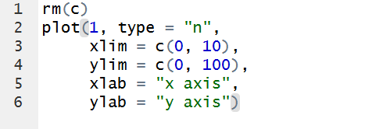
Output:
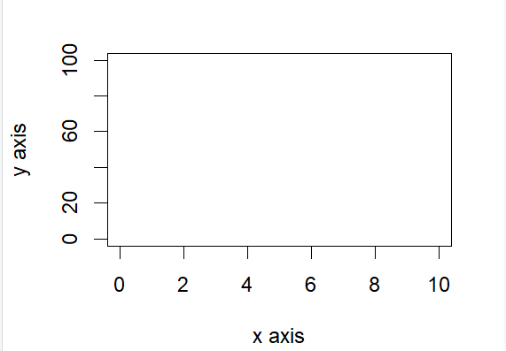
Result:
Hence the output is verified successfully.

